**Architecture Design Documentation For**

**Online Ride Sharing**

Bcs163001

Abdul Rehman Aamir

Contents

Introduction 3

1. About Project 3

1.1 Project Description 3

2. Architecture 5

2.1Architecture overview 5

1. COMPONENT NO.1 5

• **Login** 5

2. COMPONENT NO.2 6

• **Sign Up** 6

3. COMPONENT NO.3 7

• **Generate challan** 7

4. COMPONENT NO.4 8

• **generate pass** 8

5.COMPONENT NO.5 9

• **Cancel ride** 9

6.COMPONENT NO.6 10

# **Introduction**

## **About Project**

This project is a software based project about Online Ride Sharing System. This system is based on three main intended users including Admin, Students and Drivers. This project is about 12 Weeks or 84 days .This project is an extension of an existing one. This project includes new function including face detection or voice detection. This will give the students a little authority to cancel the ride whenever they are willing to and to monitor the bus. Another feature of this product is that students will be able to register online and can generate pass and challan through this app sitting in their home. This project was made for university (Capital University of Science And Technology). This project will be much feasible because of the time duration (12 weeks) and addition to this, the technical team was well qualified enough to run the whole project. The publicity of project is the competition upon other well design software causes this a global competition. The organization’s technical staffs have great technical skills to make the features efficient. The market is quite warm at the current time making it quite profitable.

## **Project Description**

The project goal of this project is to satisfy the needs of students i.e. managing bus issues. This project’s end result gives the ability to three groups including students, drivers and Admin. The goal of this particular project is to give a specific space for all three intended users including first the admin:

The Admin will have the authority to allot specific bus to a specific driver. The admin has some chores on maintenances that the admin will have the authority to change bus routes many more. The second intended user will be students which will have the following option on which the software for them works: the student will have a sign up chart where they have to get themselves registered, then they have select the route and a suitable bus according to the route, generating the challan paying it and generating the pass will get them fully registered, students also have the facility to cancel the ride or to notify drivers the new address. The third very most important user is Driver, which has two things. Able to access he map and see what students queue he have to pick and the second thing is notify the students and the admin in case of emergency.

# **Architecture**

## **2.1Architecture overview**

The main architecture of this software is give user a brief detail that what this product provides. The end users are teacher, student and admin. The main intended audience is Teacher as it says Teacher Course Management System. The functions are all list above. The input and output of the user are mainly these three individual’s data indeed.

# **COMPONENT NO.1**

### **Login**

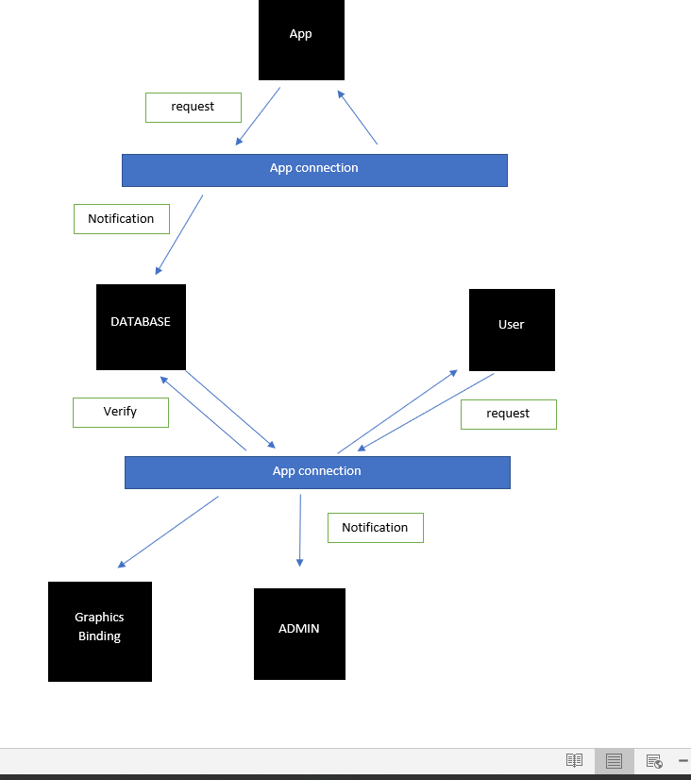

# **COMPONENT NO.2**

### **Sign Up**

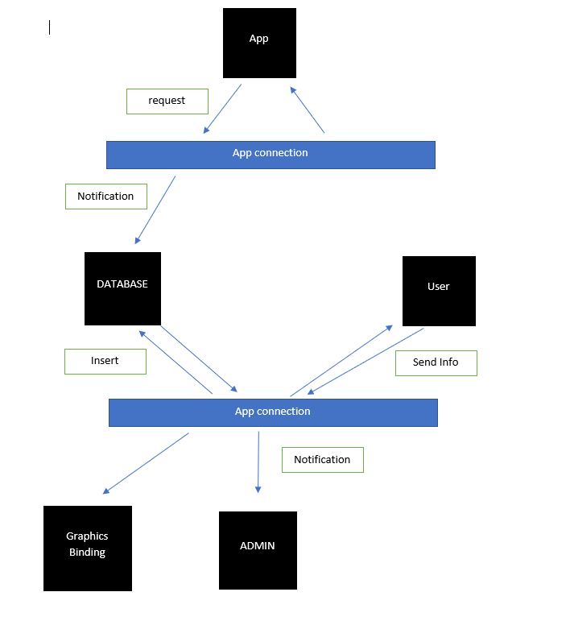

# **COMPONENT NO.3**

### **Generate challan**

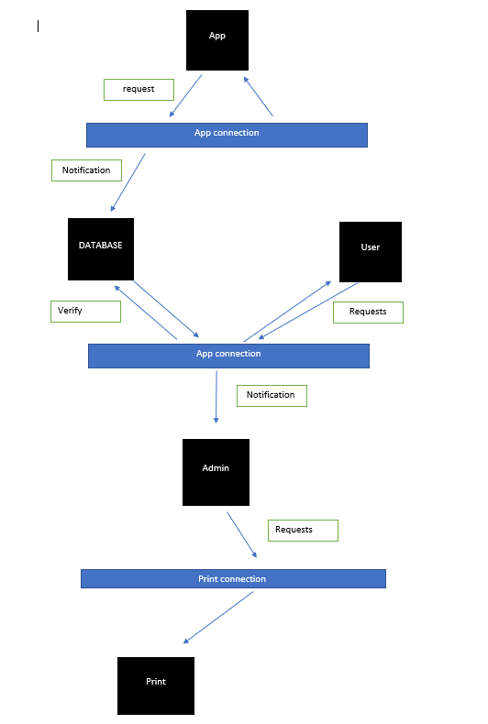

# **COMPONENT NO.4**

### **generate pass**

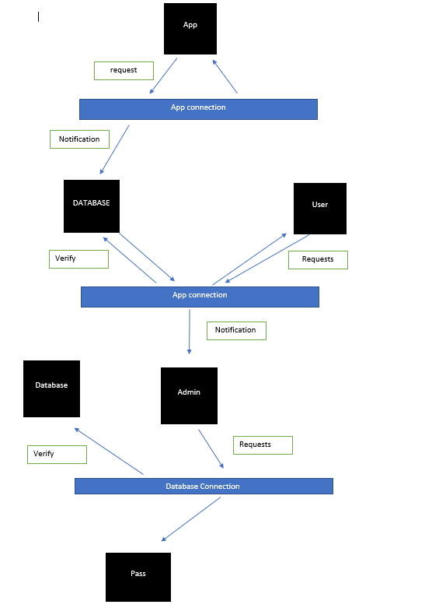

# 5.COMPONENT NO.5

### **Cancel ride**

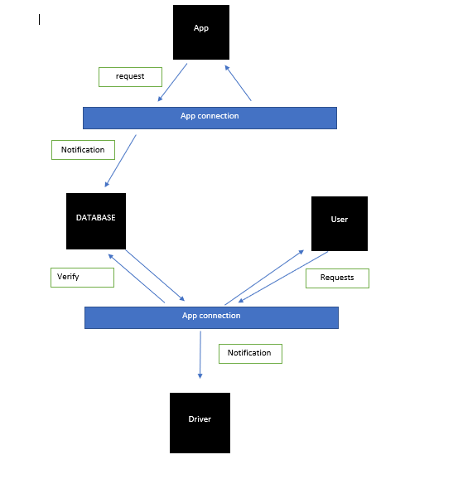

# 6.COMPONENT NO.6

* **BUS MONITORING**

